**Program 19: Demonstrate the SQLite database operations create,read,update and delete on a table.**

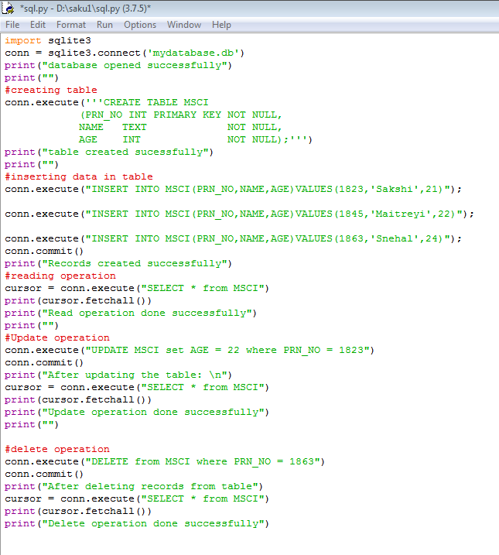

**Output:**

